AI Use Declaration Form
Course: Introduction to Artificial Intelligence
Lab Title: Lab 1 Part A — Uninformed Search Algorithms
Student Name: ___ESBERT EFUA TAWIAH BORDEN
Student ID: __22222028____________________________________________________
GitHub Repository Link: __https://github.com/EsbertEfuaBorden/lab0-git-practice.git
Date Submitted: ___5/06/2026_______________________________________________

1. AI Use Summary
Question | Student Response
Did you use any AI tool for this lab? | YES
Estimated percentage of the work influenced by AI | 15 %
Did you attach evidence of AI use where applicable? | NO

2. Details of AI Use
Complete the table below for each AI tool used. Add more rows where necessary.
Name of AI Tool Used | Purpose for Using the Tool | Prompt or Instruction Given to the Tool | Part(s) of the Work Influenced by the Tool | How I Verified, Edited, or Improved the AI Output
Claude | To understand the work | Can you help me understand this portion? | Question 5 Task 2&3, Q.6, Q.7 | I did not improve anything, because I don’t understand it.

3. Attachment of AI Output Evidence
Where required, attach evidence of AI use. Tick all that apply. Add more rows where necessary.
Evidence Type | Attached? (Yes, No, N/A) | File Name
AI-generated draft | Yes | 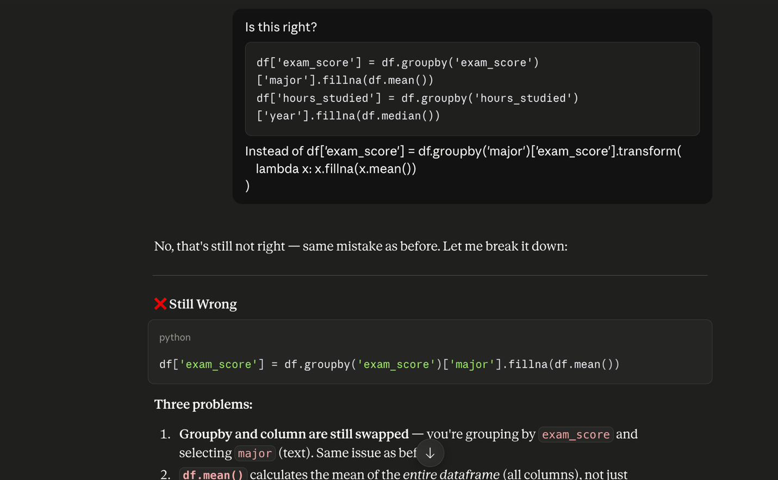
Prompt history | Yes
Screenshot of AI interaction | Yes | 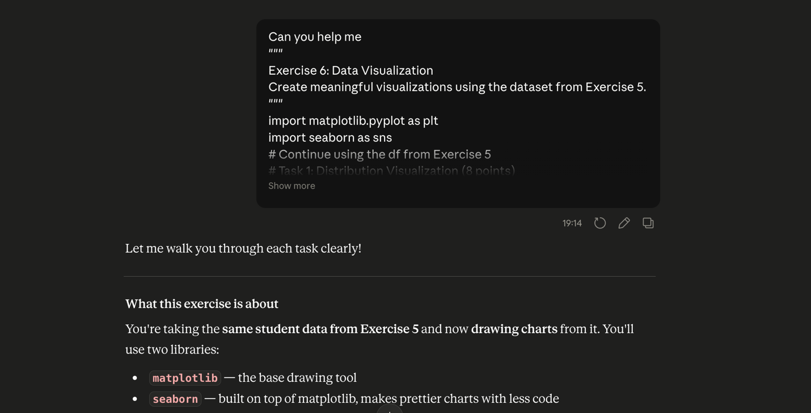
Exported AI conversation | Yes | 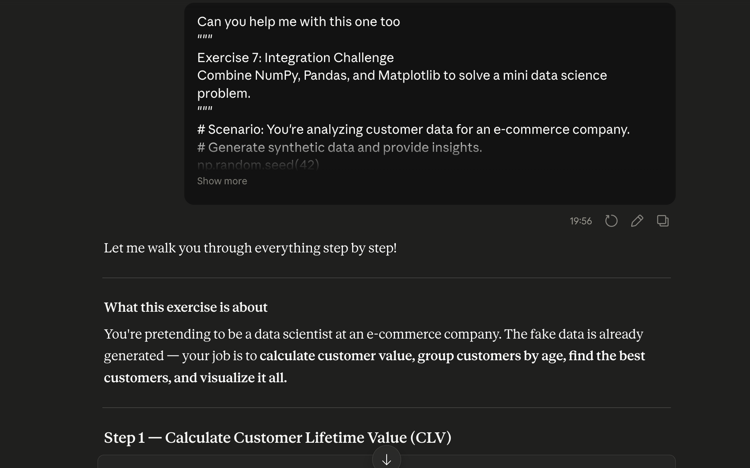
AI-generated code snippet | Yes
Revised version showing student input | Yes

4. Student Declaration
I declare that:
Declaration Statement | Response (Yes/No)
The submitted work is my own work. | Yes
Any use of AI tools has been clearly declared in this form. | Yes
The prompts, instructions, and AI-generated outputs have been disclosed where applicable. | Yes
I reviewed, tested, edited, and improved any AI-generated content before submission. | Yes
My AI usage does not exceed 25% of the entire work. | Yes
I understand that undeclared or excessive AI use may be treated as academic misconduct. | Yes

Student Signature: ____________B.E.E.T_______________________________
Date: _______5/06/2026____________________________________

